web_infrastructure_design

0-simple_web_stack
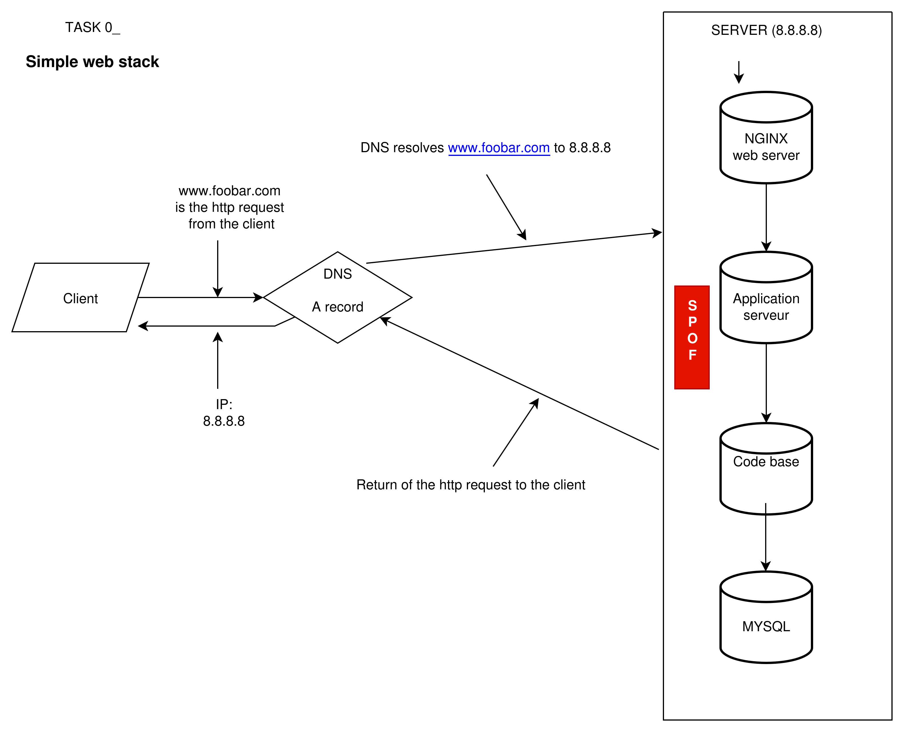

- What is a server
A server is a physical or virtual machines that provides computing ressources (CPU, RAM, Storage, network) to host services such as web servers, applications, and databases

- What is the role of the domain name
A domain name is a human-readable address that maps to an IP address, making it easier for users to access websites instead of remembering numbers.

- What type of DNS record www is in www.foobar.com
It is an A record (IPv4 address record) that points the domain name to the server’s public IP address (8.8.8.8).

- What is the role of the web server
The web server (Nginx) serves static content and forwards dynamic requests to the application server.

- What is the role of the application server
The application server executes the application code, processes business logic, and generates dynamic responses.

- What is the role of the database
The database (MySQL) stores persistent data, such as users, posts, or transactions, which can be queried and modified by the application.
- What is the server using to communicate with the computer of the user requesting the website
It uses the HTTP/HTTPS protocol over TCP/IP to send and receive requests and responses.

The problem with this type of infrastructure is that if the SPOF (Single Point of Failure) fails, the entire system will be out of service.
The same situation occurs if a maintenance operation is performed on the server: the whole infrastructure will remain unavailable for the duration of the maintenance.
In addition, this infrastructure is not designed to handle a large number of connections; even a simple DDoS attack could take down the server and make the entire website unavailable.

1. Distributed web infrastructure

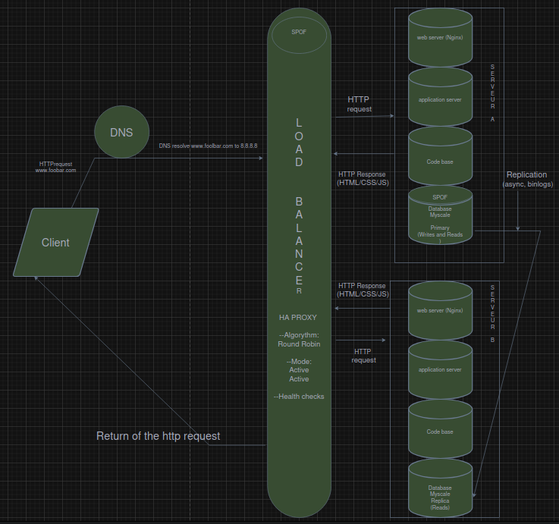

- What distribution algorithm your load balancer is configured with and how it works
My load balancer is configurated with Round Robin algorythm,
the algorythm distributes the requests in a rotating order first server A and then the B after the B it goes back to the A

- Is your load-balancer enabling an Active-Active or Active-Passive setup, explain the difference between both
This set-up is an active/active configuration why ?
both server are working the load balancer distributes the requets on both servers the A is the primary (write/and read) and the B(read/only) if the set up was passive only the server A would receive the request, as soon as the server A is unavailable due to an ddos attack failure or maintenance the server B would do the needful to handle the request and database of server B would be set on write and read instead of read only,

- How a database Primary-Replica (Master-Slave) cluster works
The Master handles all write operations (INSERT, UPDATE, DELETE). The Replica receives a copy of all changes from the Master and handles read operations. If the Master fails, the Replica can be promoted to become the new Maste

- What is the difference between the Primary node and the Replica node in regard to the application
Applications send write queries to the Primary node and read queries to the Replica node. This separates the workload and improves performance
- Explain what the issues are with this infrastructure:

- Where are SPOF
The SPOF are :
- The load Balancer if it fails the trafic will not be redirected between the server A & B

- The mySQL database on server A because this one is set on write/read, if it unable to write no operations can be written which results in a loss of data

- Security issues (no firewall, no HTTPS)
No https to secure the connection
no monitoring
no secure communication between components

- monitoring
No metrics on the serveur component like
ram
hdd
no logs or alerts if the serveur is down

2. Secured and monitored web infrastructure

